**Final Exam: LOGIC / Problem Solving**

**BATCH 2024**

**{2h00}**

FIRST NAME

LAST NAME

CLASS

* Paper with Boolean simplification rules allowed
* Chatting and talking to other students is forbidden.

|  |  |
| --- | --- |
| EXERCISES | POINTS |
| Exercise 0 – Multiple choice - form | 12 |
| Exercise 1 - General | 4 |
| Exercise 2 - Boolean | 10 |
| Exercise 4 - Range | 24 |
| Exercise 5 – Flowchart | 30 |
| Exercise 6 – Encoding | 20 |
| **TOTAL** | **100** |

**Exercise 1: General**

1. What are the 3 numbers after each series below? (2 pts)

1, 1, 2, 3, 5, 8, 13, 21, 34

1, 3, 9, 27, 81, 243, 729

1. Find the correct number for the boxes below. (2pts)

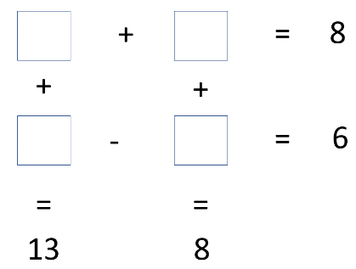

4.5

3.5

3.5

9.5

**Exercise 2: Boolean expression**

Demonstrate these equalities using the 9 simplification rules you have learnt:

1. !(A and B) and (!A or B) and (B or !B) = !A

*(B or !B) = True*

*!(A and B) = !A or !B*

*(!B and B) = False*

!(A and B) and (!A or B) and (B or !B) = (!A or !B) and (!A or B) and True

= (!A and !A) or (!A and B) or (!B and !A) or (!B and B)

= !A or (!A and B) or (!B and !A) or False

= !A and (True or B or !B)

= !A and True

= !A

!(A and B) and (!A or B) and (B or !B) = !A

1. (A or C) and ((A and D) or (A and !D)) = A

(A or C) and ((A and D) or (A and !D)) = (A or C) and ((A and (D or !D))

= (A or C) and (A or True)

= (A or C) and A

= (A and A) or (A and C)

= A and (C or True)

= A and True

= A

(A or C) and ((A and D) or (A and !D)) = A

**Exercise 3: Ranges**

1. Draw the shape corresponding to the boolean expression
2. . (x > 3 and x < 5) or (y < 3)

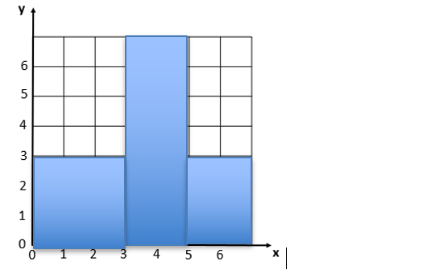

1. . (x>2) and not((x>3 and x<4) and (y>2 and y<6))

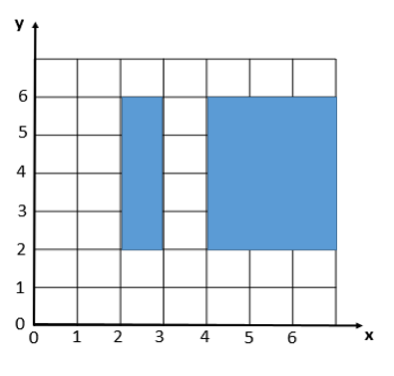

1. Write the boolean condition for this grid.

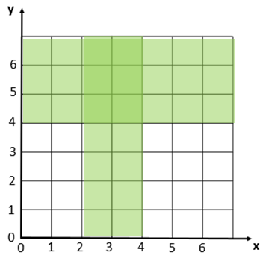

Expression:

(x > 2 and x<4) or y > 4

**Exercise 4: Flowcharts**

1. Draw a tree of conditions that describe the cases below

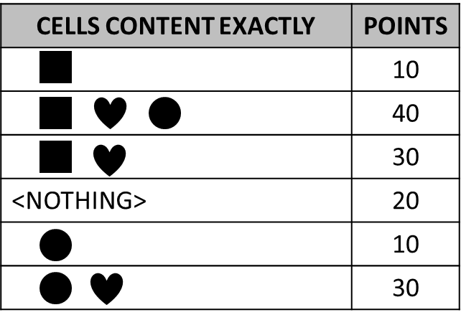

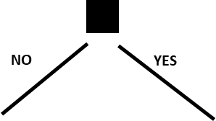

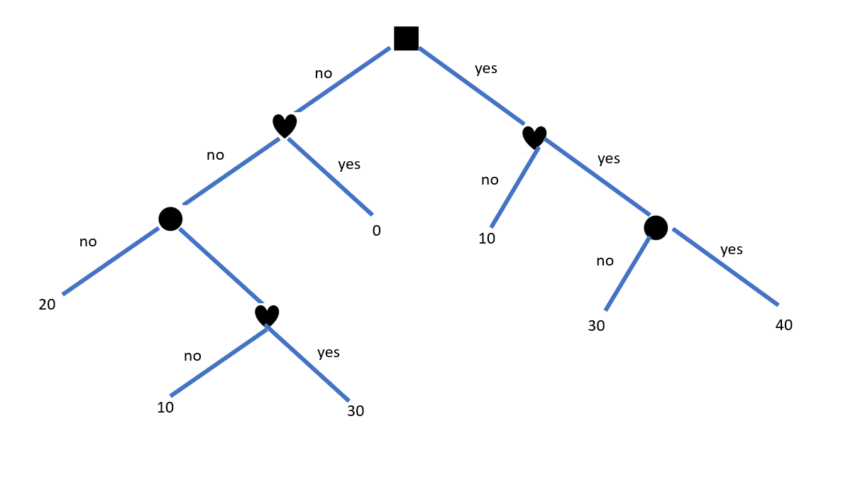

1. 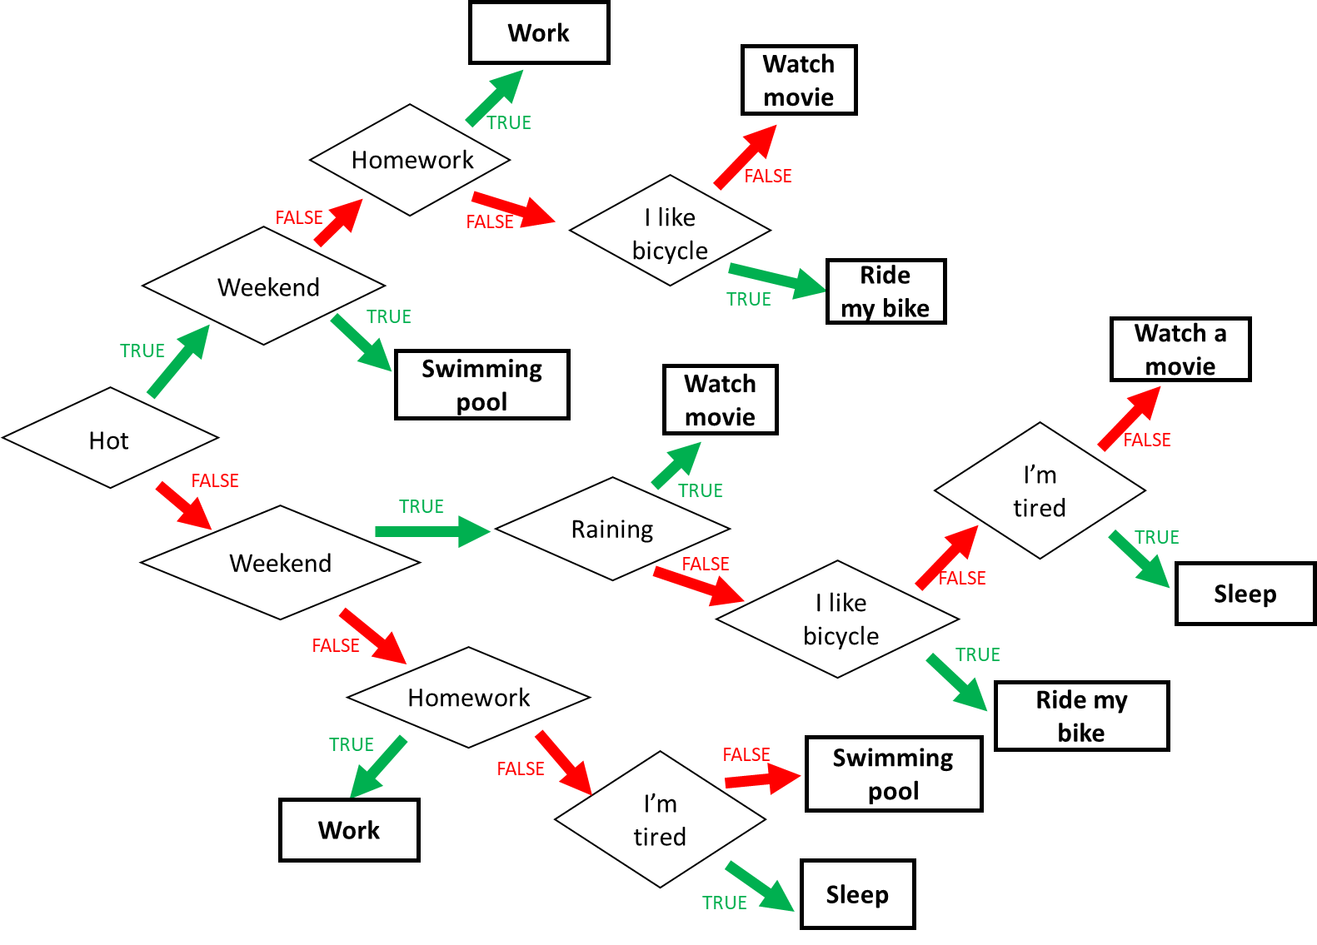Decide where I go on holidays, using the flowchart above.
2. It is Monday, it’s hot and I have homework. What do I do?

I work

1. It’s Sunday, it’s cold, it’s not raining, I don’t like bicycle, and I’m not tired. What do I do?

I watch a movie

1. It’s Friday, it’s cold and raining, I’m tired but I don’t have homework. What do I do?

I sleep

1. When do I ride my bike? **Give a Boolean expression**.

It’s hot and it’s not the weekend and I don’t have homework and I like bicycle

Or

It’s cold and It’s weekend and it isn’t raining and I like bicycle

1. Find the Boolean expression of **RED** of this flowchart

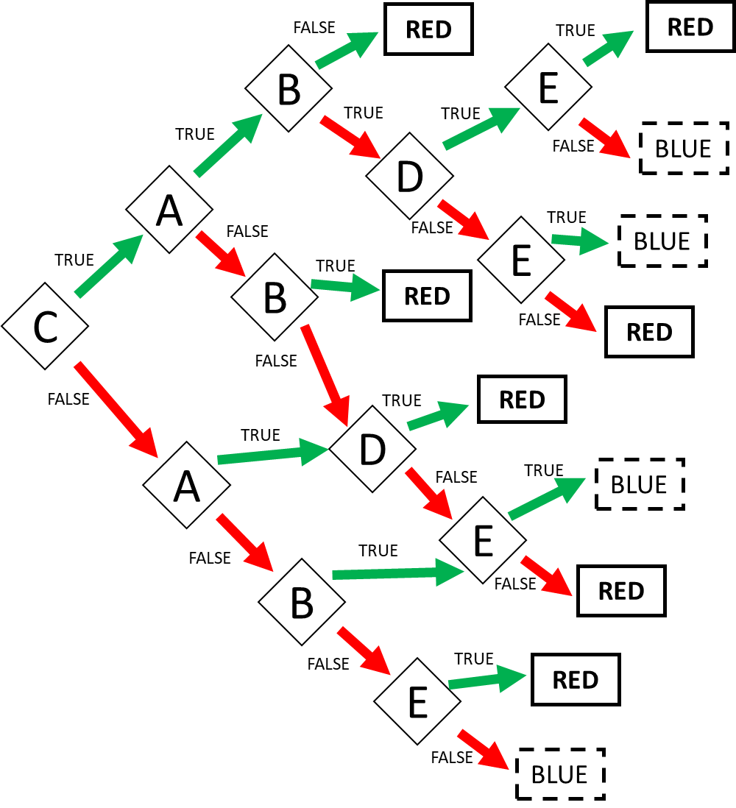

Expression: **RED** = = CA!B or CABDE or CAB!D!E or C!AB or C!A!BD or C!A!B!D!E or !CAD or !CA!D!E or !C!AB!E or !C!A!BE

Expression: **RED** (FALSE) = CA!B OR CAB!D!E OR C!A!B!D!E

**Exercise 5: Encoding**

* First 2 characters “GU”, repeated many times (min repetition is 1 - max repetition is 6)
* Then 1 character “@”, repeated many times (min repetition is 1 - max repetition is 6)
* Then 1 number (0-9)

Examples:

GUGU@@@@8

GU@@@@@@9

GUGUGUGUGUGU@1

**Q1**. Propose an **encoding** **structure** to encode this image.

|  |  |
| --- | --- |
| Encoding parts | Encoding values (in binary) |
| Number of repetitions of the text GU: 1…6 | 001…110 |
| Number of repetitions of the sign @: 1…6 | 001…110 |
| The number at the end: 0…9 | 0000….1001 |
|  |  |

**Q2**. What is the total **size** of your encoding? Give explanations.

Encoding size: we need size 10bits

*Explanation:*

Part1: 1010 that mean text of GU repeated from 6 times

Part2: 1010 that mean sign of @ repeated from 6 times

Part3: 1001 that mean the number at the end is 9